Unit 101
Singing Techniques and Performance

Don’t be afraid to ask if you have a question!
It’s important to learn to be aware.

We experience feed back from our voices in two main ways
Aurally
Physically

Vocal Technique – What you need to know.
- Becoming aware – physical/mental warm up.
- Posture
- Breath Control In
- Breathing in (abdominals and diaphragm)
- Breathing in (chest and back)
- Breath Control Out
- Supported breath out for singers.
- Intonation/Range
- Resonance.
- Voice Placement/Tone
- Projection
- Flexibility/Musicality
- Diction. Vowels. Consonants.
- Vocal Health Care

TEST 1: Recorded presentation. Analyse techniques. Need to know variety of techniques for each area. Which ones you practice and why?

TEST 2: Written Log book and Tutor assessment showing set targets and reviewing progress in improving vocal technique.

Why is singing technique important?
- Vocal health – your voice is your ‘business’
- Stamina – 6 shows and 2 matinees a week?
- Creativity – what you can imagine, you can then create.
- Making the best of what you got – sounding good.

Great website: www.singwise.com - see “Anatomy of the Voice”.
- Becoming Aware – Physical and Mental warmup

You can’t learn to sing unless first you know what you already do. Become aware to find out!

Then being aware in the moment of what you do – you can change it at your will. You’re in control.

To become aware in the moment can massively enhance your learning and performing experience.

ALWAYS do mindful exercises preliminary to singing lessons, practices and performances.

Breathing Exercises
Sitting or standing. Close eyes if helps.
- Become aware of your normal breathing – all the sensations.
- Look around your body for unnecessary tensions.
- Breath into those tensions.

Movement Exercises (Gentle Yoga)
- Standing tall – become aware of breathing and posture
- Raise arms slowly over head. Hold. Return arms slowly to sides. Feel all the physical sensations.
- Raise arms again – bend to one side. Bend to the other. Return and lower arms (improves posture)
- Roll shoulders slowly feeling all sensations (loosens shoulders)
- Drop head to chest, stretch back of neck, roll head from side to side (loosens tensions in the neck)
- Drop head to chest, curl forwards at waist, loose arms. Hang and breath into lower back. Return to standing. (encourages deep breathing for singing).

These types of exercises are the first ones you should always do before singing.

- Posture
Important for:
- Good skeletal frame to support good vocal and breathing muscle alignment.
- Blank canvas on which to create a character.
- Good basis for learning singing technique.
- Looks great!

Posture:
- Feet hips width apart and ‘grounded in the earth’.
- Head drawn up to the heavens from the crown (long neck)
- Shoulders dropped back and down.
- Ribcage open.
- Pelvis in the middle (not thrust forward or arching spine)
- Soft knees.
- Arms relaxed and just hanging loose. Hands relaxed.

How to get a better posture:
- Yoga exercises can help.
- Back against a wall. Heels/Buttocks/Shoulders touch the wall. Don’t arch the back.
- Singing whilst lying on the floor.
- Stretching

3. Breath Control - In
Why do we need good breathing?

- We sing on the breath – there is no sound without breath.
- Singers need deep breaths for long phrases.
- Good breathing supports good vocal tone.
- Good breathing refreshes the voice (stamina)
- Good breathing helps with nerves.

3a. Breathing In (abdominals and diaphragm)

The lungs are like balloons. They expand both sideways and downwards on inhale.

The diaphragm contracts to draw air into the body (compare with CPR).
The abdominal muscles – if firm – restrict this contraction and affect the ‘downwards’ movement of the lungs.

Singers need lots of breath so relaxing the abdominals on the in-breath allows the diaphragm to descend a bit further.

Dancers rarely ‘let go’ of their abdominal muscles.

Singer’s breath is like a sleepers breath only standing up and conscious!

How to do it:
- Good posture.
- Relax abdominal muscles (until you could not make a sound)
- Hands on belly. Feel the normal breathing you do
- Deepen that ‘normal breathing’
- Drop jaw to breathe in.

This technique is particularly useful for dealing with nerves.

It is also particularly useful as it refreshes your voice on (pretty much) every in-breath to promote stamina and healthy singing.

IT IS OF PARAMOUNT IMPORTANCE!

Breath Control – In - Continued
3b. Intercostals and back

This is to help the lungs to expand sideways.

It’s still an expansion of what we do normally.

Intercostals:
- Good posture.
- Finger tips touching over ribs.
- Feel fingertips move apart a little on in breath.

Combine with abdominal breathing.

Back breathing:
- Sit on chair (or crouch like a skier)
- Feel back open when breathing in.
- Hold breath and stand up normally.
- Sing or ‘ssss’.

Create a similar feeling in the back when breathing in standing position.

Practice:
Be aware of one area of breathing (abdominals/diaphragm) to start with.
When that becomes easy, try combining abdominal awareness with intercostal awareness.
Finally add in the back to be aware of all breathing principles to give you the best breaths.

Mouth breathing.

Breathe in through mouth (not nose)
Relax vocal cords – breath goes in quicker – no sound.
Just feel the breath in the body – don’t need to hear it.
Loud breathing comes across microphones.
Use audible breathing sounds in songs for character development.

- Breath Control – Out
Singing Support
It takes effort to sound effortless. But it needs to be the RIGHT sort of effort! Muscular balance is the answer.

Vocal folds and vocal resonators are excited by sub-glottal air pressure.
Air pressure affects the quality of sound and pitch.

Babies are chaotic Masters of sound production.
Babies have 3mm long vocal folds but can scream in an intense and projected way for hours and never lose their voices – you were a baby once!
They are subconscious – we have unguidedly learnt to control our voices and bodies due to our culture.
Listen to your own body. You already know how to do this.
You already have every muscle you need ready to do this.

Explore and experiment.
So let’s explore what we already do that hasn’t been ‘tampered’ with that can help us to support our singing voices.

- Start from totally relaxed abdominals.
- Laugh, cough, whoop to find awareness of muscles we use.
- Have a go at using the muscles soundlessly with control.

Using the right muscles in the right way.
- Pulling up pelvic floor engages the
- Abdominals which stops the relaxation of the
- Diaphragm which keeps air pressure high in the
- Lungs which are also controlled by the
- Ribs to create high air pressure under the
- Glottis (vocal folds) and onwards…..to the next lesson!

Do SSSS, Brrr and RRrrr exercises to work on breath pressure awareness, muscular control awareness and breath control.

Remember to always relax abdominal muscles on breathing in!
(Same muscles used on inhale and exhale. Don’t worry, can be confusing for a while but you’ll get it.)

- Intonation/Range

Intonation is a posh way of saying “singing in tune”.

- Children’s start to develop pitching skills from the age of 7. It slowly develops over time with practice.
- Some people can do it more easily than others. Some have to learn.
- Some people (about 4% of the country only) are amusiacs and can’t sing in tune – aka ‘monotones’.
- Some people can hear if someone else is singing out of tune but not themselves!

The best way to self-enhance your intonation is to concentrate and be very aware of yourself when singing. Be self-critical.

Singing teachers can help by doing the following:
- Demonstrating with a voice rather than keyboard
- Using a voice that is the same as yours (man/woman)
- Not starting to learn a song with words – just on la.
- Plenty of simple repetition.
- Improving your technique (breathing etc)

Range

Range is the range of your voice. Also known as the ‘tessitura’

To find your range:
Sing down to your lowest note. Check it on a tuner or piano.
Swoop up to your highest note and check that on a tuner or piano.
You have your vocal range.

6. Resonance.

A note is made by the vocal cords/folds.

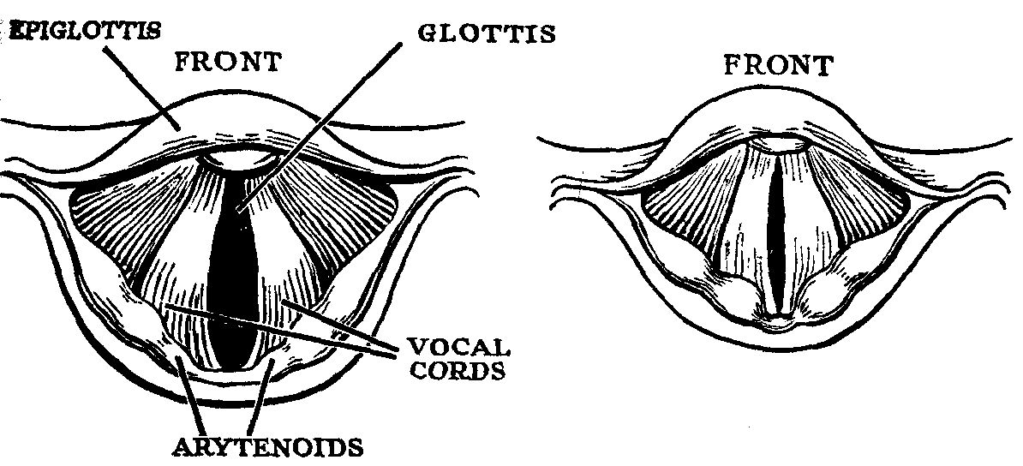

Open – breathing – adducted Closed – singing - abducted

Things that affect a note:

- Length and Mass of cords (mass – like lower strings on cello cf higher strings) So - Fatter and longer = Lower
- General shape of larynx area and muscles etc in there
- Sub-glottal air pressure affects the folds ability to make pitch and what the resonators can do with it once the sound wave created by them leaves into the vocal tract.

What happens?
Sound waves are made by the vocal folds.
They pass into the vocal tract cavities (resonators)
The shape/size of the resonators affects the tone (vocal colour) coming out of the mouth.

The Vocal Resonators
There are 3 places where the voice resonates before leaving the body.

In the pharynx
In the nasal cavity
In the mouth

(ps…your voice doesn’t resonate in your chest ‘cos the chest is fill with spongy tissue and you need a cavity to make resonance. What you feel is a sympathetic sensation of the pharynx resonating. It’s just like feeling a wall resonating to a loud rock band. The wall isn’t making the band resonate – the band makes the wall resonate. The feeling of a buzzy chest IS useful though.)

Cavity SHAPE is important to sound quality. Think of making the same sound in an echoey hall and compare it to your bedroom. The cavity is different affecting the quality of the sound. This is the same in your vocal tract.

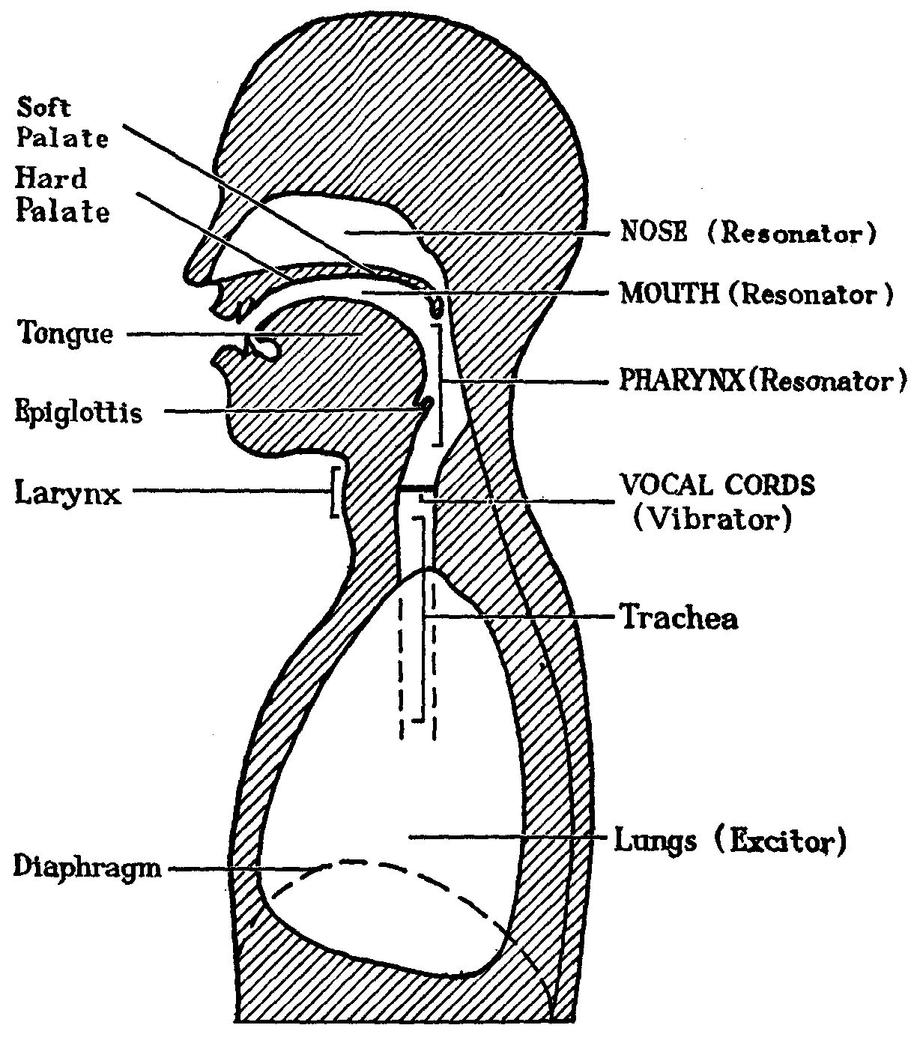

- Voice placement/Tone

Use – tongue, larynx, soft palate, lips and jaw to play with voice placement.

Balance is the key
Too much mouth and too little larynx=thin reedy tone
Too much pharynx = heavy dull tone
Too much nose = nasality
Too little nose = tight whining twang etc etc etc

You can play with your voice tone and placement to change its sound for the style specific needs of your music/character.

‘TWANG’ (singer’s formant) AIRY
VIBRATO WHITE TONE
SPACE/YAWNY(LARYNX DOWN) THIN SOUND (LARYNX UP)

Different characters and styles of music require different voice placement.

- Thin Fold – Light, whispery vocal tone suited to mid-high vocal range. Casual low volume/intimate/jazz.

- Thick Fold - Mid/low vocal range. Richer tone with more resonance. Uses abdomen and vocal muscles to produce sounds. Vibrato. Diva songs.

- Twang - Imitate a child’s ‘nanana’ voice. American/attitude tone. Bright. The sound seems to resonate in the nasal passage. Pop/Music Theatre/Classical (with lower larynx)

- Aspirate – Breathy sound. Expel breath slowly using ‘hah’ sound. Combine the breath with an “Ah” musical note. Put hand infront of mouth and feel air. Jazz/Pop

- Belt Quality – Full, powerful chest voice. Imagine you are shouting ‘hey!’ in a noisy room. There will be muscular stress in your neck and abdomen.
There may be a slight ‘growl’ to your vocal tone. If wanting to take this tone high in the range – GO TO A PROPER BELT TEACHER. Dangerous voice to use too much without proper tuition. It can damage a young healthy voice. Music Theatre/Diva

- Head Voice/Falsetto - Similar in tone to Thin Fold voice but used for your upper vocal range. Music Theatre/Classical

- Growl - The classic blues/rock voice actually constricts the vocal chords to create a ‘raspy’ quality. Imitate a dog growling. There will be tension/pain at the back of your throat. YOU ARE DELIBERATELY DAMAGING YOUR VOICE IF OVER USED. Pop.

Vocal Attack
There are a variety of tones you can use at the ‘onset’ of a vocal line:
- Aspirate attack: breath sound first
- Glottal attack: a vowel sound “oh…uh”
- Creak attack: a slight crack/groan
- Growl attack: an aggressive roar

Vocal Release
There are several ways of releasing vocal tones:
- Aspirate decay: the tone fades into breath
- Glissando: a slight fall off / upward push
- Compressed: no fade. An instant decay.
- Creak: the tone cracks / falls apart
- Burst release: an extra syllable of expelled air ‘uh’

(Source: “Popular Singing” by Donna Soto-Morettini - Central School Speech & Drama LIPA)

8. Projection.

Lots of people shout sing to do this and end up damaging their voices believing that pushing the voice in some way will ‘project’ it over a band or orchestra.

Ideal ‘projection’ is when your voice is:

- Balanced between all the resonating cavities of the vocal tract
- Free flowing of sound (free from constrictions)
- Has singer’s formant, (with all the overtones present and a “ring/twang”)
- Pure (the timbre is not made to be something that it isn’t naturally)
- Supported by good, steady breath pressure.

One of the resonant qualities (aka twang, focus, ring or ping) is more officially called the ‘singer’s formant’. It can really help with ‘projecting’ your voice into the audience because it cuts through the orchestra’s texture.

The ‘Singer’s Formant’

- When we sing, we make a complex sound.
- This complex sound is a harmonic spectrum made up of peaks that are produced by acoustic strength.
- The peaks (showing acoustic strength) are called Formants (F).
- F0 is the fundamental frequency. So when you sing A (A=440hertz) – your vocal folds vibrate 440 times per second!
- F1 and F2 are overtones/harmonics on F0 created by the vowels you sing. Better vowel shaping = better F1 and F2 = enhanced resonance and projection.
- F3, F4 and F5, (very simply) if bunched together will create the ‘singer’s formant’. This resonant peak occurs at 2,500-3,500 Hz, well higher than the 500 or so hertz produced by an orchestra and cuts through their complex sound.

Developing the ‘Singer’s Formant’

This singer’s formant can be developed with training by doing the following:
“The pharynx must be dilated to at least six times wider than that of the larynx tube opening.” Sundberg 1974.
We do exercises and listen and feel for this (or look for it on a spectrogram). The singer’s formant is audible in twang, opera and belt.

Exercises such as ‘ng’ slides, ‘nyeh’, ‘miaow’ etc encourage the singer’s formant.

- Flexibility/Musicality

Flexibility can be developed by doing vocal exercises.
- Scales
- Arpeggios
- Trills
- Acrobatics
- Dynamics (louds and softs)
- Exercising the whole range – NG slides.

Musicality

Musicality is developed by:
- Critically listening to the style you want to sing – listen for voice placement/improvisation/styles/physical movements/sound colour/word usage.
- Copying
- Creating something new!

10. Vocal Health Care

For full vocal health DO NOT:

- Smoke (breath capacity goes first, coughing – marijuana is very bad ‘cos of high burning temp)
- Drink alcohol before singing
- Speak in dry atmospheres (air conditioning is bad too – DRINK LOADS of water)
- Whisper
- Converse over loud music/noises
- Shout at sport matches
- Eat chocolate or any dairy 6-8 hours before going on unless drinking something like a lemon drink or have garlic to clear the chords
- Cough – use a drink or swallow or yawn instead if you can

When speaking DO NOT:

- Over relax
- Mumble
- Speak off support
- Whisper

Testing for a hurt voice – Know your voice.

- Do regular exercises so that you know your voice well and can spot problems. NG slides every single day are a good quick guide.
- Vocalise gently on a ‘ha’ – keep quiet as poss. Your voice may tremor/waver if unhappy.
- Loss of voice with no pain – the body is keeping you from using the voice protecting itself.

An Ill Voice?

1 Hoarse, scratchy (Keep an eye out for possible Reflux affecting a voice. Hoarseness in the morning for eg which goes later)
2 Changes noticeable to friends/family
3 Radical change in pitch
4 Breaks in voice (Speak ‘above’ any soreness, pain or break in the voice. Hum down to find the break and speak above it. Place it in the ‘facial mask’ and use a ‘smaller’ voice (more focused)
5 Vocal fatigue (for no obvious reason)
6 Tremors
7 Pain
8 Loss of voice – not due to a cold.

Vocal Health Care cont.

Fixing a voice

Colds/Flu – Voice Care:
- Drink loads of water – it needs lubricating
- Drink lemon and honey
- Onion soup
- Raw garlic
- Inhale steam – 5 mins every 3-4 hours
- Olbas oil or Friar’s Balsam (+plenty of water to drink)

Regular/Common Voice Loss after singing:
Check the following for
- Head/neck – posture creating constriction of neck
- Spine – posture
- Shoulders – Lifted? Tense?Pulled Back? Rounded? All bad!
- Breath – Too shallow? Disconnected? Irregular?
- Voice – Pushing? Feeling abuse in throat? Glottal attack? Shouting or screaming more than usual?
- Jaw – Tense? Clenched?

Yes to any? – use exercises and relaxation techniques – be AWARE when you’re singing to avoid the above.

Fixing a voice with a more serious problem?
Most difficult voice problems can be solved without surgery.
These days, nodes are fixed by a week’s non speech rather than burning the nodes off the chords. The nodes are a little like a bruise on the chord. If they’re burnt off, the skin will not repair and will never heal, but rest and silence will ease the bruise.

TOTAL REST for 2-5 days. NO SPEACH AT ALL...NO WHISPERING...NOTHING.
If symptoms persist for 7-14 days – seek professional help. You may need to see a vocal specialist called an Otolaryngologist

Diction 1
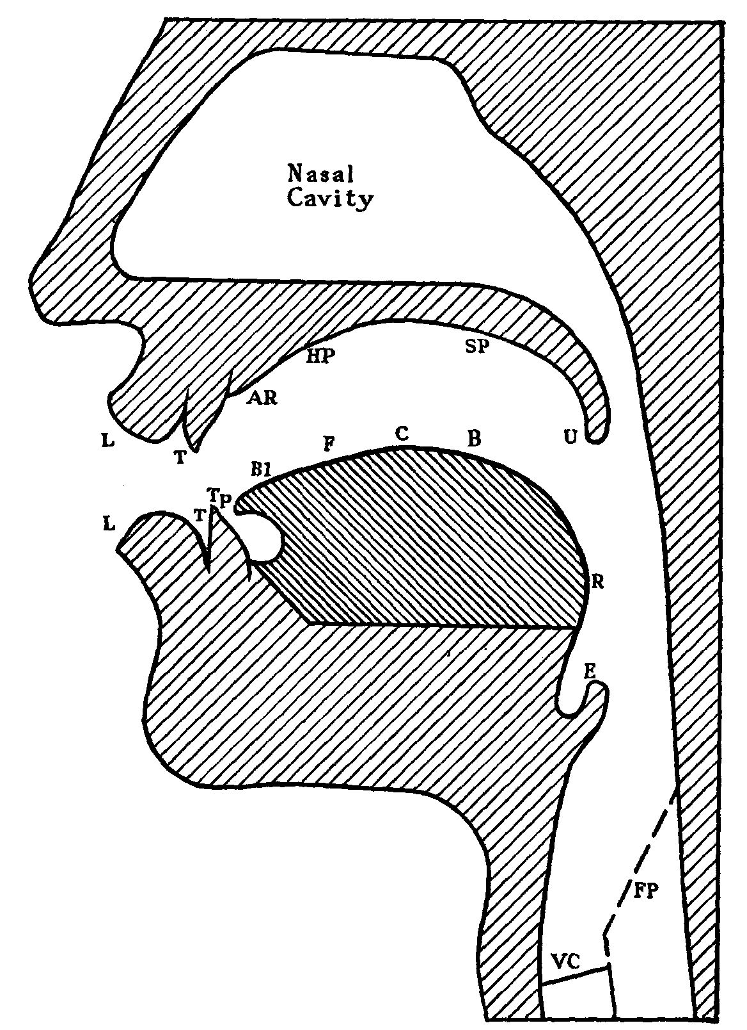
Speech organs used in Singing….
L – Lips
T – Teeth
TP – Tongue Tip (1)
Bl – Tongue Blade
F – Front of Tongue (2)
C – Centre of Tongue
B – Back of tongue (3)
R – Rear of tongue
E – Epiglottis
VC – Vocal Chords (folds) (4)
FP – Food Pipe
U – Uvula
SP – Soft Palate
HP – Hard Palate
AR – Alveolar Ridge

Finding areas of the Tongue
Tip – point (some consonants like t, d)
Blade – under top teeth ridge when tongue at rest (some fricatives).
Front – under hard palate (tongue vowels)
Centre – partially under hard and soft palate (tongue vowels)
Back – Under soft palate (plosives like k, g)
Rear – part connected to larynx

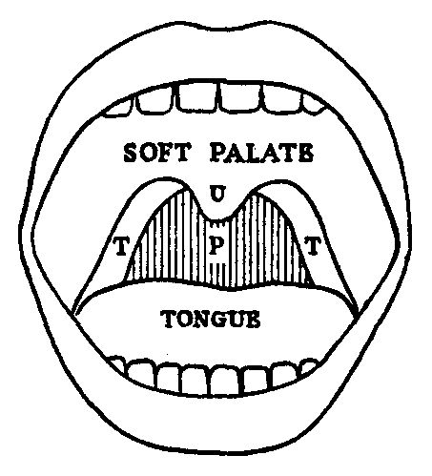
You can look at some of the speech organs in the mirror….
U – Uvula (rises on high notes usually)
T – Tonsils (if you have them)
P – Pharynx (upper part of throat)
Soft Palate (Velum) rises when smiling – creates brighter vowel sounds.

Vowels
Vowels shape the free passage of sound and are always vocalised
We sing on vowels.

Vowel control can be learnt in 4 ways:
1 Knowledge of how made and the speech organs performing
2 Control of the speech organs and muscular skill (intelligent exercising will gain this)
3 Ear Training: Aural recognition of a sound (manner and place of articulation)
4 Connection between sensation and singing.
Types of Vowels
Production….
Tongue Vowels: Eh, Ee, Ay
Lip Vowels: O, Aw, Ooo
Neutral vowel (uses both): Ah

Pronounciation….
Pure Long Vowels: Ee, Ah, Aw, Oo
Pure Short Vowels: A (apple), Eh (bed), I (ink), O (sob), u (Good)
Dipthongs: A continuous vowel slide from one vowel to another.

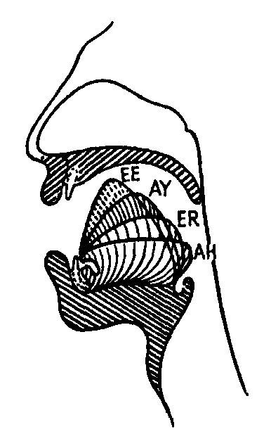
Lip Vowel Practice
AH – O (orange) – AW (audience) – Oo (oodles)

Two types of Ooo
Ooo + Aw = Classical/Older music theatre
Ooo + Ee = Pop/ Modern Music theatre

Tongue Vowel Practice
AH – Eh (fair) – AY (say) – Ee (easy)

Dipthongs

- There are approx. 8 English dipthongs (depending on accent)
- Dipthongs have 2 vowels in them. You slide from one to the other in speech.

In singing, one vowel in the dipthong is elongated to hold the note –
the other is quick!
Closing Dipthongs
Low (oh – oo)
Loud (ah – oo)
Light (ah – ee)
Lane (eh – ee)
Loin (aw – ee)

Centering Diphongs
Leer (ee – uh)
Lair (eh – uh)
Lure (ee – aw)

After a while you hear the tone coming to the point where the movement is made and also the movement contributing to the sound.

Don’t emphasize the point where the movement is made!
Diction 2
Consonants

No point in learning all those words if we can’t hear them!
Words VERY important in Music Theatre.

Consonant practice is called Articulation
Consonants are made by the coming together of 2 speech organs to make a sound
Enunciation is the grouping of vowels and consonants to make connected speech.
Finish and start every word clearly and cleanly – economy and efficiency

Types of Consonants

Plosive – passage of sound/air is fully stopped – eg, ‘b’ and ‘p’
Continuants – restricted air flow (fricatives/nasals/laterals)

Fricative – fff, sss,
Affricative –ch, dj
Nasal – mmm
Lateral - l
Semi-vowels – y and w

Voiced (vocalised) – ‘b’ (put hand on neck to feel voiced ness)
Breathed (unvoiced or unvocalised)- ‘p’(no resonance in neck now)

‘b’ is a ‘voiced plosive consonant’
‘p’ is a ‘breathed plosive consonant’

Timing
1 Coming together of muscles
2 Holding
3 Releasing

Parts of the vocal mechanism used for consonants –

Labial – Lips
Bi-labial – Both lips
Dental – Teeth
Alveolar – ridge behind top teeth
Lingual – Tongue
Velar – Soft palate
Palatal – hard palate
Glottal – vocal folds/chords. Glottis is the SPACE between the vocal chords

Plosives
For clarity of words in singing but without disturbing vocal line, make sure they are firm, crisp, clear but not over-done. Over articulated sounds have a small vowel to be heard in the final position.

p,b (bi-labial)

Put hand infront of mouth to feel explosions of air – clear light and clean

t,d (lingual/alveolar)

Quick clean and sharp sound
‘t,t,t,t,t....’ quickly and then ‘d,d,d,d,d,d,....’

k,g (labial/palatal and labial/velar)

Hard consonants for singers as they are made where the tongue makes vowels.
“keg, cog, kack, gag”

Aspiration

P, T, K are unvoiced – beware making them - P’h’AH, T’h’AH, K’h’AH Don’t make it too prominent or ‘tea for two’ could become ‘tsea for tsoo’ or “t’he for t’who”!

B, D, G are voiced so you get no aspiration. With B, D or G in final positions watch they don’t become ‘Big (er), bad(er), dog(er)’. Begin voiced and end breathed

Tongue Twisters to improve your plosive pronunciation

Peter Piper picked a peck of pickled peppers.
A peck of pickled peppers Peter Piper picked.
If Peter Piper picked a peck of pickled peppers,
Where's the peck of pickled peppers Peter Piper picked?

A big black bug bit a big black dog on his big black nose!
Black background, brown background.

Send toast to ten tense stout saints' ten tall tents.
Two tiny tigers take two taxis to town.

Do dire dandy’s dish delicious delicacies or do dashing dudes deliver death?

How can a clam cram in a clean cream can?

Gobbling gorgoyles gobbled gobbling goblins.
The great Greek grape growers grow great Greek grapes.

Continuants – Fricatives and Affricatives

A continuant consonant – the air continues to flow through the consonant.
Two types – voiced and breathed.

Fricatives
s, z (lingual/alveolar) aka sibilant
S – breathed and Z – voiced
Problems: Many people have a lisp. Clear pronunciation depends upon position of tongue, on condition of air channel and on dentition. More info available.

f, v (labial/dental)
F – breathed and V – voiced
Don’t have top teeth overhanging bottom lip.

th, th (lingual/dental)
Th – breathed as in the word ‘breath’ and Th – voiced as in the word ‘then’
Problems: Many people use ‘f’ and ‘v’ for ‘th’ and ‘th’ confusing the word ‘three’ and ‘free’.

Sh, zh (lingual/dental or palatal) aka sibilant
Sh – breathed as in the word ‘sure’ and Zh – voiced as in the middle of the word ‘measure’.

Affricatives
An affricatives is a mixture of a plosive and a fricative. There is a slow release of a plosive resulting in addition of a fricative consonant.

ch, dj (lingual/alveolar)
Ch – breathed as in ‘chin’ and Dj – voiced as in ‘gin’

Tongue Twisters

If Sally sells sea-shells by the sea-shore then surely there should be sea shells in sight.

Zizzi’s zizzy zipper zips

Five frantic frogs fled from fifty fierce fishes
Vincent viewed valuble valley villas and vowed vengeance very vehemently
Something in this thirty-three acre thicket of thorns and thistles thumped and thundered towards a bothered and mithered Matthew Botherton.
Surely as she measured the gin June chose, she should have shown pleasure as the cheer arose.
Continuants – Nasal, Lateral, Semi-vowels etc

Nasal
M (bi-labial)
Lips should bounce apart.

N (lingual/alveolar)

Ng (lingual/velar)
Flexible back of the tongue to say this correctly.

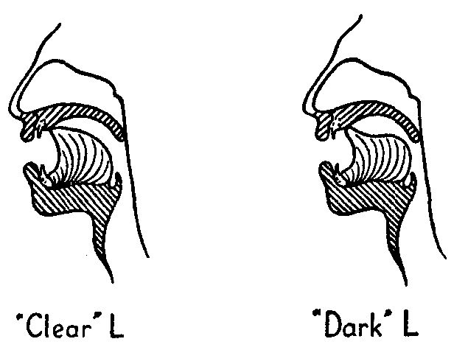
Lateral

L (lingual/alveolar)
Two types of ‘l’.
Clear ones at the beginning of words such as ‘light’
Dark ones at the ends of words such as ‘pull’

Semi-vowels

W (bi-labial)
A consonant that is really a vowel in sound. W sounds like ‘oo’

Y (lingual/palatal)
Another consonant that is really a vowel. Y sounds like ‘ee’

When ,where, why, what
Don’t need to be unvoiced. Use voiced. Context will dictate between ‘weather’ and ‘whether’.

W = OO rapid lip voiced glide
Y = EE rapid tongue voiced glide

Trill
R (lingual/alveolar)
These can be rolled, flapped or approximated.
Rolled (Italian – front of tongue)
Rolled (French – back of tongue)
Flapped (a quick flap of the tongue)
Approximated (no actual restriction)
Rhotid (American type of R)
Try not to make them sound like ‘w’ – “vewy wed woses”!

